**Code**

1. public int test(int a, int b, int c){
2. int s;
3. boolean IsTriangle;
4. if ((a<b+c)&&(b<a+c)&&(-c<a+b)){
5. IsTriangle = true;
6. }
7. else{
8. IsTriangle = false;
9. }
10. if (IsTriangle){
11. if((a==b)&&(b==c)){
12. s = 1;
13. }
14. else if((a!=b)&&(a!=c)&&(b!=c)){
15. s = 3;
16. }
17. else{
18. s = 2;
19. }
20. }
21. else{
22. s = 4;
23. }
24. return s;
25. }

**Graph**

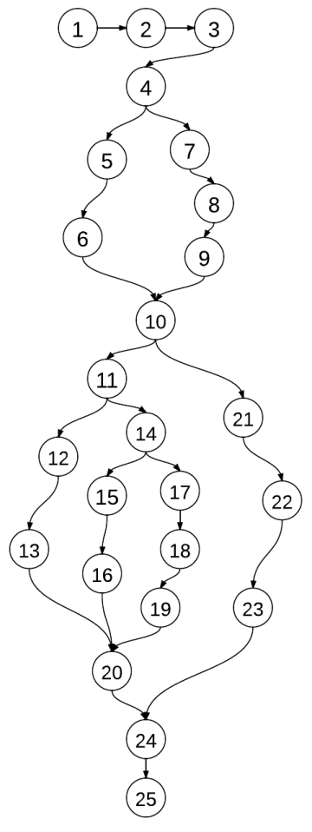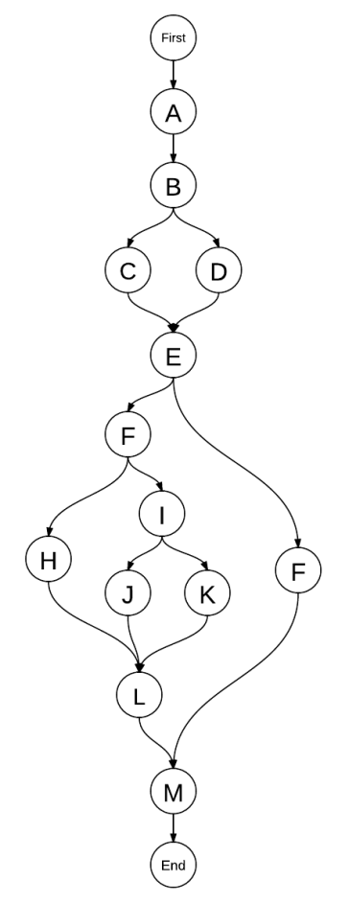

Program Graph DD-path Graph

**C1: Cover Every DD-Path**

**Model**

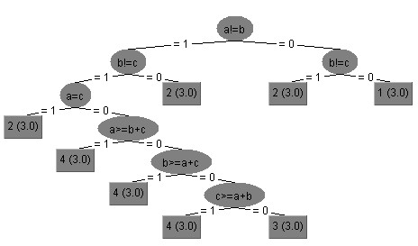

|  |  |  |  |  |  |
| --- | --- | --- | --- | --- | --- |
|  | | DD-Path Coverage | Input | Output(code) | Output(model) |
| 1 | P1 | First, A, B, C, E, F, H, L, M, End | 6, 6, 6 | Equilateral | Equilateral |
| P2 | First, A, B, C, E, F, I, J, L, M, End | 11, 13, 7 | Scalene | Scalene |
| P3 | First, A, B, C, E, F, I, k, L, M, End | 7, 7, 3 | Isosceles | Isosceles |
| P4 | First, A, B, D, E, G, M, End | 4, 9, 2 | Not a Triangle | Not a Triangle |
| 2 | P1 | First, A, B, C, E, F, H, L, M, End | 53, 53, 53 | Equilateral | Equilateral |
| P2 | First, A, B, C, E, F, I, J, L, M, End | 2, 3, 5 | Scalene | Not a Triangle |
| P3 | First, A, B, C, E, F, I, k, L, M, End |  |  |  |
| P4 | First, A, B, D, E, G, M, End |  |  |  |